Case Study Report



**Tech Saksham**

Data Analytics with Power BI

**360-Degree Business Analysis of Zomato Delivery App using Power BI**

**Government Arts & Science College – Dharmapuri**

|  |  |
| --- | --- |
| **NAAN MUDHALVAN ID** | **NAME** |
| 1CC8FC6734D7CECAA3F429E0943A85F1 | CHINNASAMY C |

**TRAINER NAME:** R UMAMAHESWARI

**MASTER NAME:** R UMAMAHESWARI

**ABSTRACT**

In today's digital landscape, the food delivery industry has become increasingly competitive, with platforms like Zomato striving to stay ahead by leveraging data-driven insights. The project, "360-degree Business Analysis of Zomato Delivery App using Power BI", aims to empower Zomato with comprehensive data analysis and visualization capabilities. By harnessing the advanced features of Power BI, this project seeks to delve deep into Zomato's vast data reservoirs, extracting valuable insights regarding customer behavior, market trends, and operational efficiency.

Through meticulous analysis of key metrics such as order volumes, delivery places, popular cuisines, and customer feedback, the project endeavors to provide Zomato with actionable insights to optimize its business operations, enhance customer experience, and maintain its competitive edge. By synthesizing data analytics and visualization techniques, this project aspires to facilitate informed decision-making processes within Zomato, ultimately contributing to its digital transformation journey. The outcomes of this project hold the potential to revolutionize Zomato's approach to business strategy, fostering innovation, efficiency, and customer-centricity in the ever-evolving landscape of online food delivery services.

**INDEX**

|  |  |  |
| --- | --- | --- |
| **S. No.** | **Table of Contents** | **Page No.** |
| 1 | Chapter 1: Introduction | 04 |
| 2 | Chapter 2: Services and Tools Required | 06 |
| 3 | Chapter 3: Project Architecture | 07 |
| 4 | Chapter 4: Modeling and Result | 09 |
| 5 | Conclusion | 25 |
| 6 | Future Scope | 26 |
| 7 | References | 27 |
| 8 | Links | 28 |

**CHAPTER 1**

**INTRODUCTION**

In the fast-paced world of online food delivery, gaining actionable insights from data is essential for businesses like Zomato to optimize their operations and enhance customer experience. Leveraging advanced analytics tools such as Power BI offers a strategic advantage, enabling organizations to delve deep into their data and extract valuable insights efficiently. As the competition intensifies in the online food delivery market, Zomato recognizes the importance of adopting a 360-degree approach to business analysis to stay ahead of the curve and meet evolving customer demands.

**1.1 Problem Statement:**

In the highly competitive online food delivery industry, Zomato faces the challenge of effectively analyzing vast amounts of data to gain comprehensive insights into its business operations. Traditional methods of data analysis often fall short in providing a holistic view of critical metrics such as order volumes, customer preferences, and market trends. This limitation hampers Zomato's ability to identify growth opportunities, optimize service offerings, and enhance overall business performance. Moreover, the lack of real-time analysis capabilities further exacerbates the challenge, leading to delayed decision-making and missed opportunities for strategic initiatives.

**1.2 Proposed Solution:**

To address these challenges, the proposed solution entails developing a Power BI dashboard specifically tailored for the 360-degree analysis of Zomato's delivery app data. By leveraging Power BI's advanced analytics and visualization capabilities, the dashboard will empower Zomato to gain actionable insights across various dimensions, including order trends, customer preferences, cuisine popularity, and geographical distribution. Integrating data from multiple sources, such as transaction records, customer feedback, and market demographics, the dashboard will offer a comprehensive view of Zomato's business landscape. Its interactive and customizable features will enable stakeholders to explore and visualize data dynamically, facilitating informed decision-making and strategic planning. With real-time analysis capabilities, the dashboard will enable Zomato to respond promptly to changing market dynamics, optimize operational efficiency, and deliver superior customer experiences in the fiercely competitive online food delivery market.

Top of Form

**1.3 Feature**

* **Real-Time Analysis:**

The dashboard provides real-time analysis of Zomato's delivery app data, allowing users to monitor key metrics and trends as they unfold, facilitating timely decision-making.

* **Customer Segmentation:**

Users can segment Zomato customers based on various criteria such as location, order frequency, cuisine preferences, and spending habits, enabling targeted marketing strategies and personalized recommendations.

* **Trend Analysis:**

The dashboard identifies and visualizes trends in customer behavior, restaurant popularity, and delivery patterns, providing insights into evolving market dynamics and consumer preferences.

* **Predictive Analysis:**

Leveraging historical data and predictive analytics techniques, the dashboard forecasts future trends in customer demand, restaurant performance, and market opportunities, enabling proactive planning and strategy development for Zomato's business growth.

* 1. **Advantages**
* **Comprehensive Insights**:

The 360-degree business analysis provided by the Power BI dashboard offers a holistic view of Zomato's delivery app data, enabling stakeholders to gain comprehensive insights into various aspects of the business.

* **Enhanced Decision-Making:**

By providing real-time analysis, predictive analytics, and trend identification, the dashboard empowers decision-makers at Zomato to make informed and timely decisions, optimizing operational efficiency and resource allocation.

* **Targeted Marketing:**

Customer segmentation features allow Zomato to target specific customer groups with personalized marketing campaigns, enhancing customer engagement and loyalty while maximizing marketing ROI.

* **Strategic Planning:**

Trend analysis and predictive analytics capabilities enable Zomato to identify emerging market trends and anticipate future demand, facilitating proactive strategic planning and business expansion initiatives.

* **Competitive Advantage:**

By leveraging advanced analytics tools like Power BI, Zomato gains a competitive edge in the online food delivery market, enabling them to stay ahead of competitors by offering superior services and experiences to customers and partners.

* **Operational Efficiency:**

The dashboard's ability to analyze and visualize operational data enables Zomato to identify inefficiencies, streamline processes, and optimize resource utilization, leading to improved operational performance and cost savings.

* 1. **Scope**

The project's scope entails developing a comprehensive Power BI dashboard tailored specifically for analyzing Zomato's delivery app data. It involves integrating data from multiple sources, including transaction records, customer feedback, and market demographics, to offer a holistic view of Zomato's business operations. Through interactive features like dropdown menus and filters, users can dynamically explore and analyze data to gain deeper insights into key metrics and trends.

Beyond data visualization, the project extends to predictive and prescriptive analytics. Leveraging historical data and advanced analytical techniques, the dashboard will enable predictive modeling to forecast future trends in customer demand, restaurant performance, and market opportunities. Additionally, prescriptive analytics will provide actionable recommendations to optimize operational processes, marketing strategies, and overall business performance.

The project's ultimate goal is to empower Zomato stakeholders with timely and relevant insights to drive strategic decision-making, enhance operational efficiency, and stay competitive in the online food delivery market. By providing a comprehensive platform for data analysis and decision support, the project aims to support Zomato's growth and success in meeting the evolving needs of customers and partners.

**CHAPTER 2**

**SERVICES AND TOOLS REQUIRED**

**2.1 Services Used**

* **Data Collection and Storage Services:**

Azure Data Factory or AWS Glue: Utilized for orchestrating and automating the collection, ingestion, and transformation of data from various sources such as transaction records, customer feedback, and market demographics.

Azure Blob Storage or AWS S3: Employed for storing the integrated data securely and cost-effectively, providing scalable and reliable storage solutions.

* **Data Processing Services:**

Azure Stream Analytics or AWS Kinesis Data Analytics: Utilized for processing and analyzing real-time streaming data from Zomato's delivery app, enabling quick insights extraction and decision-making based on the latest information.

* **Machine Learning Services:**

Azure Machine Learning or AWS SageMaker: Leveraged for building predictive models based on historical data from Zomato's delivery app, enabling forecasting and predictive analytics to anticipate future trends in customer demand, restaurant performance, and market opportunities.

By leveraging these services, the project aims to establish a robust data infrastructure and analytical framework that supports real-time analysis, predictive modeling, and actionable insights generation for Zomato stakeholders. This enables informed decision-making, strategic planning, and business growth in the competitive online food delivery market.

**2.2 Tools and Software Used:**

* **Tools:**
* **Power BI:** The primary tool for this project is Power BI, which will be utilized to develop interactive dashboards for real-time visualization of Zomato's delivery app data.
* **Power Query:** This tool serves as a data connection technology, allowing users to discover, connect, combine, and refine data from various sources such as transaction records, customer feedback, and market demographics.
* **Software Requirements:**
* **Power BI Desktop:** This Windows application is essential for creating reports and designing interactive dashboards that will be published to Power BI.
* **Power BI Service:** This online Software as a Service (SaaS) platform is used for publishing reports, creating new dashboards, and sharing insights with stakeholders within Zomato.
* **Power BI Mobile:** The mobile application enables users to access reports and dashboards on the go, providing flexibility and accessibility for stakeholders to stay updated with real-time insights from Zomato's delivery app data.

**CHAPTER 3**

**PROJECT ARCHITECTURE**

**3.1 Architecture**

* **Data Collection:**
* Utilize web scraping techniques or access Zomato's API to collect comprehensive data on restaurants, customer reviews, ratings, and other relevant information.
* Gather demographic data from open data platforms or government databases to enrich the analysis.
* **Data Storage:**
* Store collected data securely in a cloud-based storage solution such as Azure Blob Storage or AWS S3.
* Organize data into structured formats conducive to analysis, ensuring efficient data retrieval and management.
* **Data Processing:**
* Preprocess and clean the collected data using tools like Python or Azure Databricks to ensure data quality and consistency.
* Perform data transformations, filtering, and aggregation to prepare the data for analysis.
* **Machine Learning:**
* Implement machine learning algorithms to analyze Zomato's delivery app data and derive predictive insights.
* Train models to forecast customer preferences, restaurant performance, and market trends, aiding in strategic decision-making.
* **Data Visualization:**
* Utilize Power BI for data visualization, creating interactive dashboards and reports to present insights derived from the analyzed data.
* Incorporate a variety of visualization techniques such as charts, graphs, maps, and tables to effectively communicate findings to stakeholders.
* **Data Access:**
* Publish developed dashboards and reports to Power BI Service, allowing stakeholders to access and interact with them online.
* Enable data access and exploration through Power BI Mobile, ensuring accessibility across various devices for on-the-go decision-making.

**CHAPTER 4**

**MODELING AND RESULT**

**4.1 Modeling :**

**4.1.1 Navigator Selection:**

To connect multiple datasets from Excel workbooks in Power BI, follow these steps for each file:

* **Open Power BI Desktop:**Launch Power BI Desktop on your computer.Click on "Get Data":In the Home tab, click on the "Get Data" option located in the ribbon at the top.
* **Select "Excel":** In the "Get Data" window, choose the "Excel" option from the list of available data sources.
* **Choose Excel Workbook:** Navigate to the location where your Excel workbooks are stored. Select the first workbook named "Africa.xlsx" from the file picker, and click "Open".

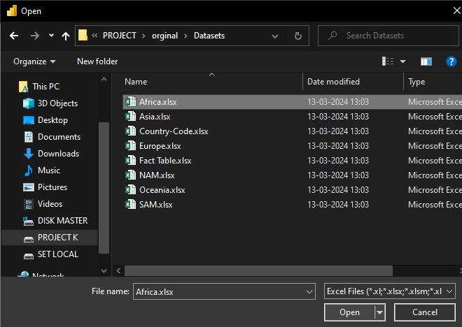

* **Wait for Data Loading:** Power BI will begin loading the data from "Africa.xlsx". Depending on the size of the dataset, this process may take some time (approximately 5-15 seconds).
* **Open Navigator:** Once the data is loaded, Power BI will display a Navigator window showing the tables available in "Africa.xlsx". Click on the table that contains the data you want to import into Power BI.
* **Click Load:** After selecting the desired table, click on the "Load" button at the bottom right corner of the Navigator window. This will import the selected table data into Power BI.

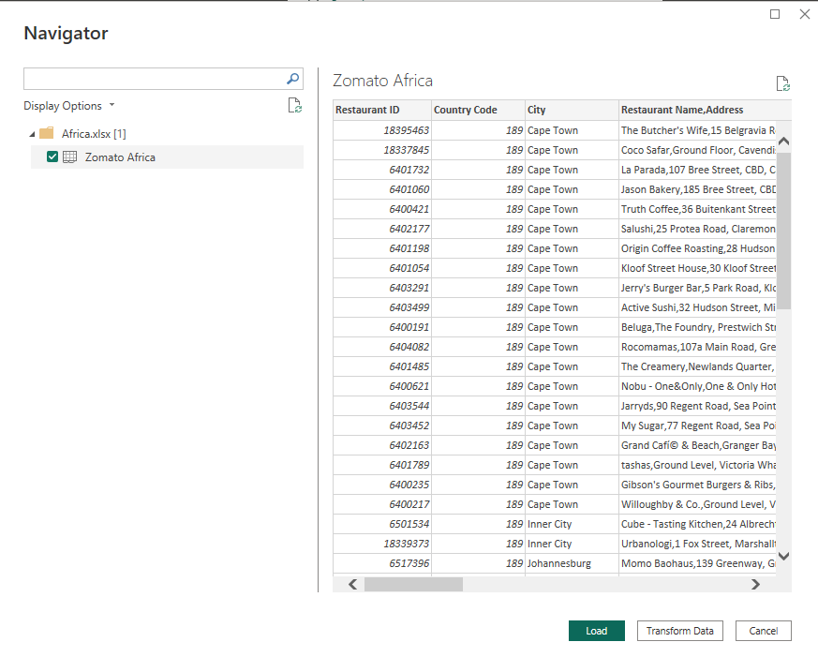

* **Repeat Steps for Other Files:** Repeat steps 2 to 8 for the remaining Excel workbooks. Each time, choose a different workbook from the file picker:
* Asia.xlsx
* Country-code.xlsx
* Europe.xlsx
* Fact table
* NAM.xlsx
* Oceania.xlsx
* SAM.xlsx
* **Verify Data:** Once all datasets have been imported, verify that the data from each Excel workbook has been successfully loaded into Power BI by checking the data view or using the Data tab.

By following these steps for each file, you can connect multiple datasets from Excel workbooks to Power BI and import them for further analysis and visualization.

**4.1.2 Query Editor**

* **Transform Data:**
* Begin by clicking on "Transform Data" to open the Power Query Editor.
* **Append Queries:**

In the Power Query Editor, navigate to "Append Queries" and select "Append Queries as New."

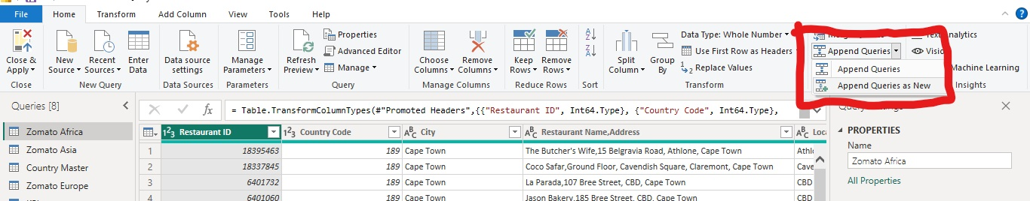

Choose two or more tables from the available options, focusing only on Zomato countries' data.

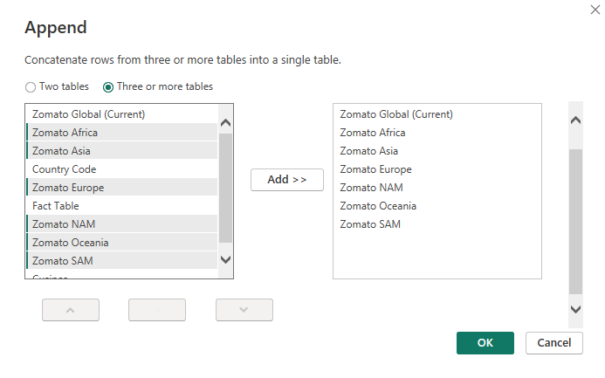

Append the selected tables and rename the resulting table as "Zomato Global.

* **Split Columns:**

Next, split the "Restaurant Name" and "Address" columns into two separate columns.

Select the column, click on "Split Column," choose "By Delimiter," and enter a comma as the delimiter

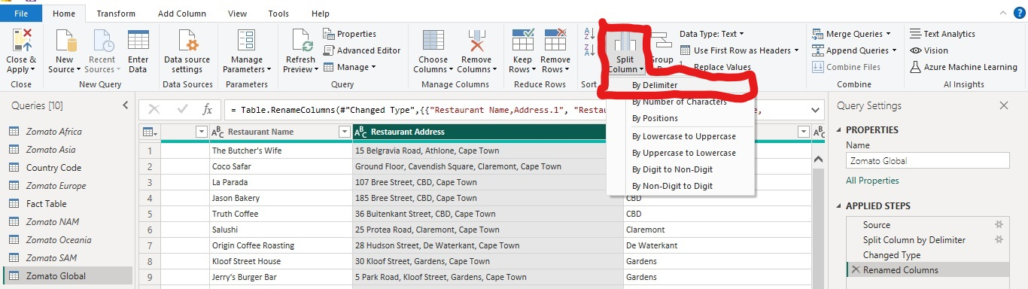

Split at the left-most delimiter occurrence and click "OK" to create two new columns (Restaurant Name, Address.1 , Restaurant Name, Address.2).

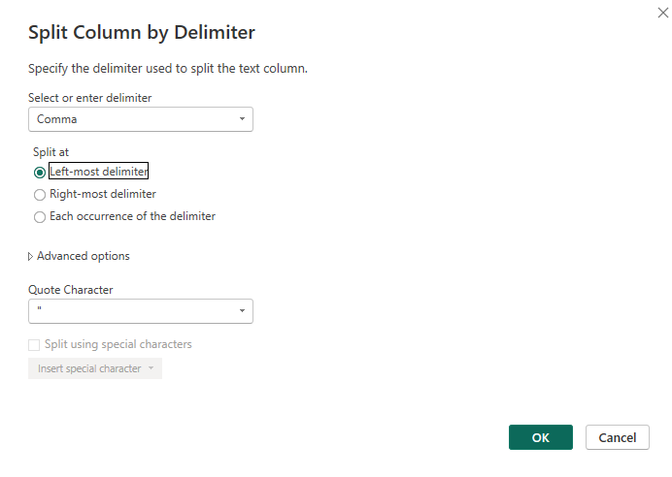

Rename the columns as "Restaurant Name" and "Restaurant Address."

* **Create Cuisines Table:**

Duplicate the "Zomato Global" table and rename it as "Cuisines."

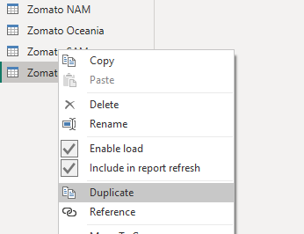

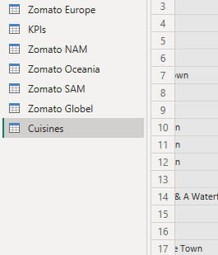

Remove all columns except "Restaurant ID" and "Cuisines."

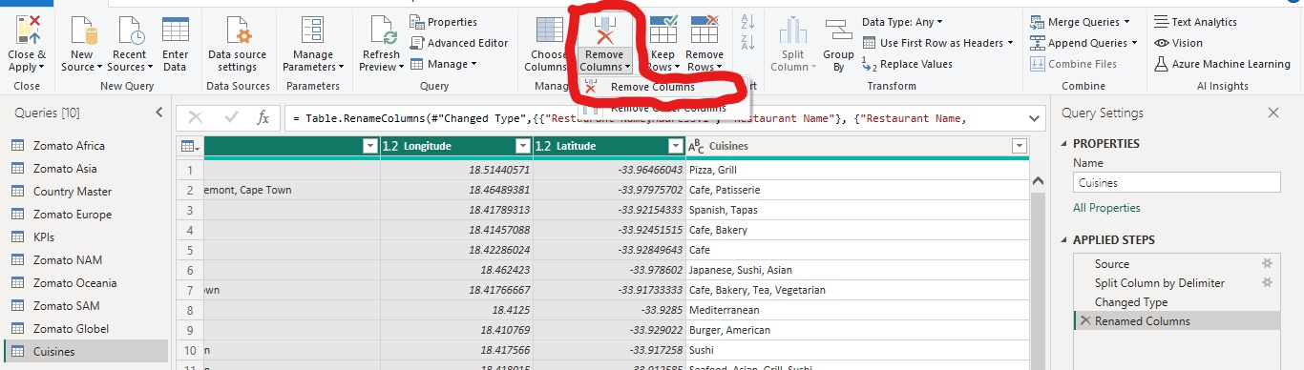

Shown As

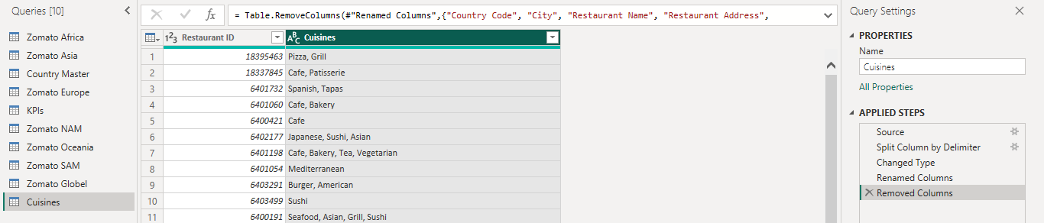

* **Split Cuisines Column:**

Select the "Cuisines" column, click on "Split Column," choose "By Delimiter," and select each occurrence of the delimiter.

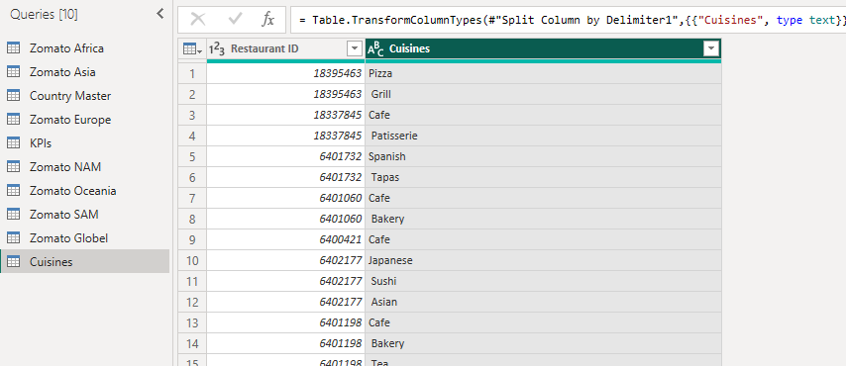

In advanced options, split into rows and click "OK."

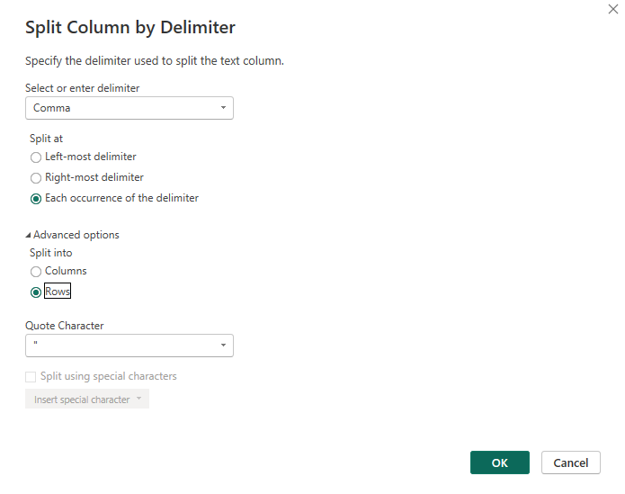

* **Prepare Country Master Data:**

Select the "Country Master" from the queries list and rename the column as "Country Code."

Remove any blank rows in the column by selecting "Remove Rows" and choosing "Remove Blank Rows."

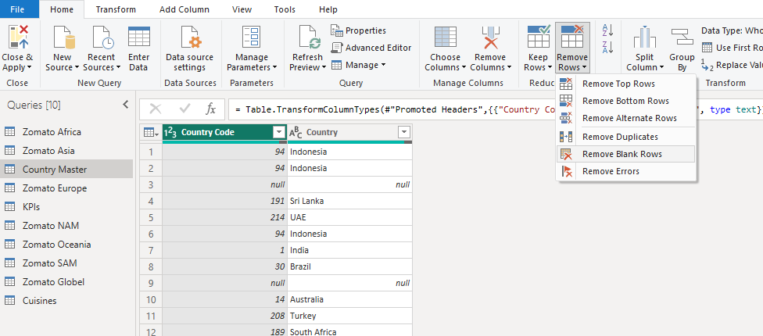

* **Prepare KPI's Data:**

Select the "KPI's" table from the queries list and rename it as "Fact Table."

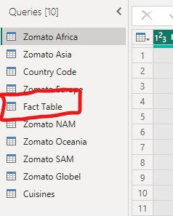

* **Disable Load for Country Names:**

Since the Zomato Global data already includes all countries, disable the load for the "Country" table.

Right-click on the table, uncheck "Enable Load," and click "Continue" to apply the changes. The country names will appear in italic font

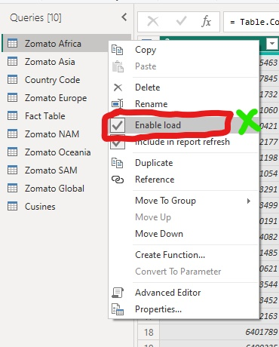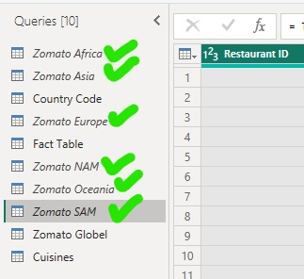

* **Close and Apply:**

Finally, click on "Close and Apply" to save the changes and apply them to your Power BI model.

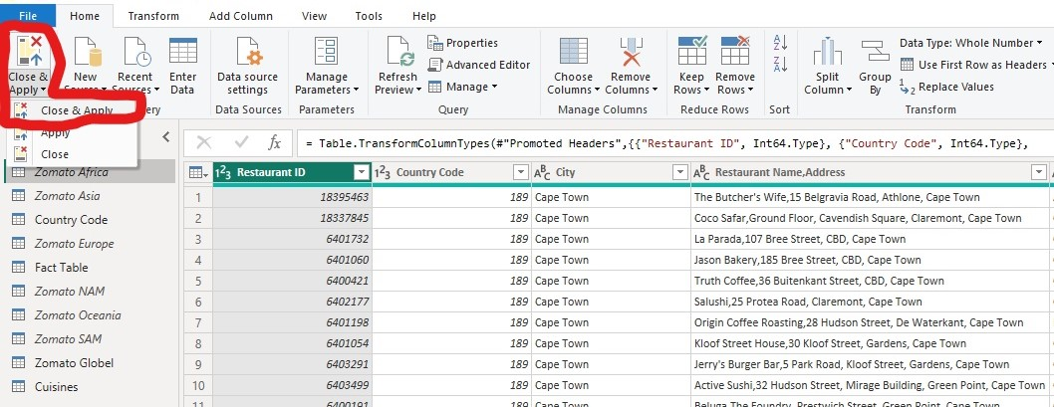

**4.1.3 Model View:**

**Here's the content written in a properly formatted manner:**

* **Table Display:**
* In the model view, you will see four tables: "Country Code," "Zomato Global," "Fact Table," and "Cuisines."
* **Establishing Relationships:**
* Establish relationships between the tables to enable seamless data integration.
* Link the "Country Code" table to the "Zomato Global" table by arranging the "Country Code" column in both tables.
* Link the "Zomato Global" table to the "Fact Table" by arranging the "Restaurant ID" column in both tables.
* Link the "Cuisines" table to the "Zomato Global" table by arranging the "Cuisines" column in both tables.

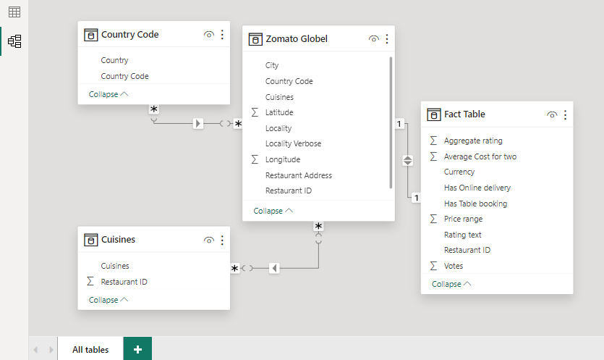

* **Linked Tables:**
* By establishing these relationships, you have created linked tables that allow for efficient data access and analysis within Power BI.
* The relationships ensure that data from different tables can be effectively combined and analyzed to derive valuable insights for decision-making and reporting purposes.

**Table View Manuipulation and Measure Creation**

In the table view of Power BI, we'll perform several functions and manipulations to enhance the data representation:

* **Creating "Rating Color" Column in Fact Table:**

Click on the "Fact Table" and create a new column named "Rating Color."

Use the following formula to determine the rating color based on the aggregate rating:

Rating color = IF('Fact Table'[Aggregate rating] = 0, "Not Rated",

IF('Fact Table'[Aggregate rating] <= 2.9, "RED",

IF('Fact Table'[Aggregate rating] <= 3.4, "Orange",

IF('Fact Table'[Aggregate rating] < 4.4, "GREEN",

IF('Fact Table'[Aggregate rating] <= 5, "Dark green", "Others")))))

Press Enter to create the new column for the rating color.

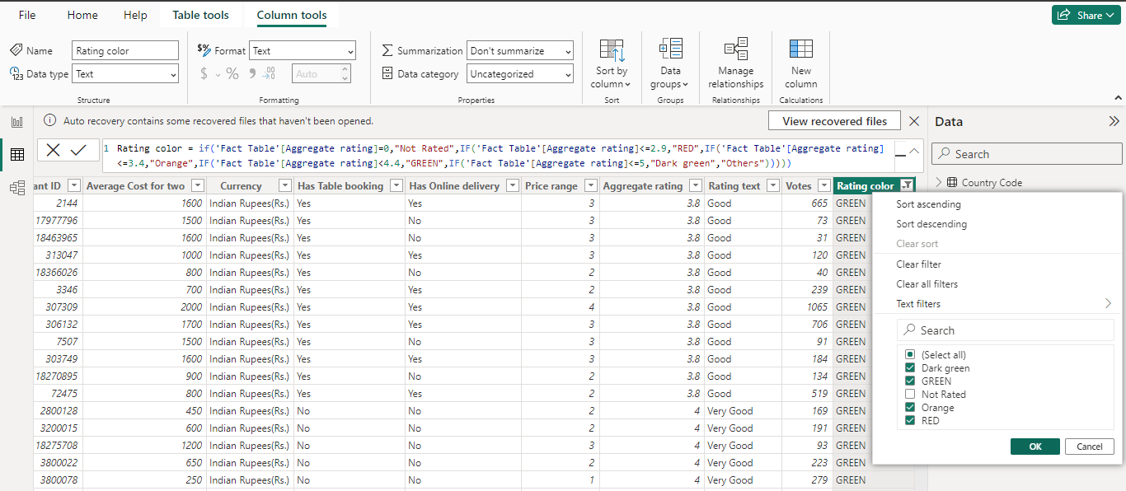

* **Creating "Continent" Column in Country Code Table:**

Click on the "Country Code" table and create a new column named "Continent."

Use the SWITCH function to assign continent names based on the country code:

Continent = SWITCH('Country Code'[Country Code],

189, "Africa",

215, "Europe",

37, "NAM",

216, "SAM",

14, "Oceania",

148, "Oceania","Asia")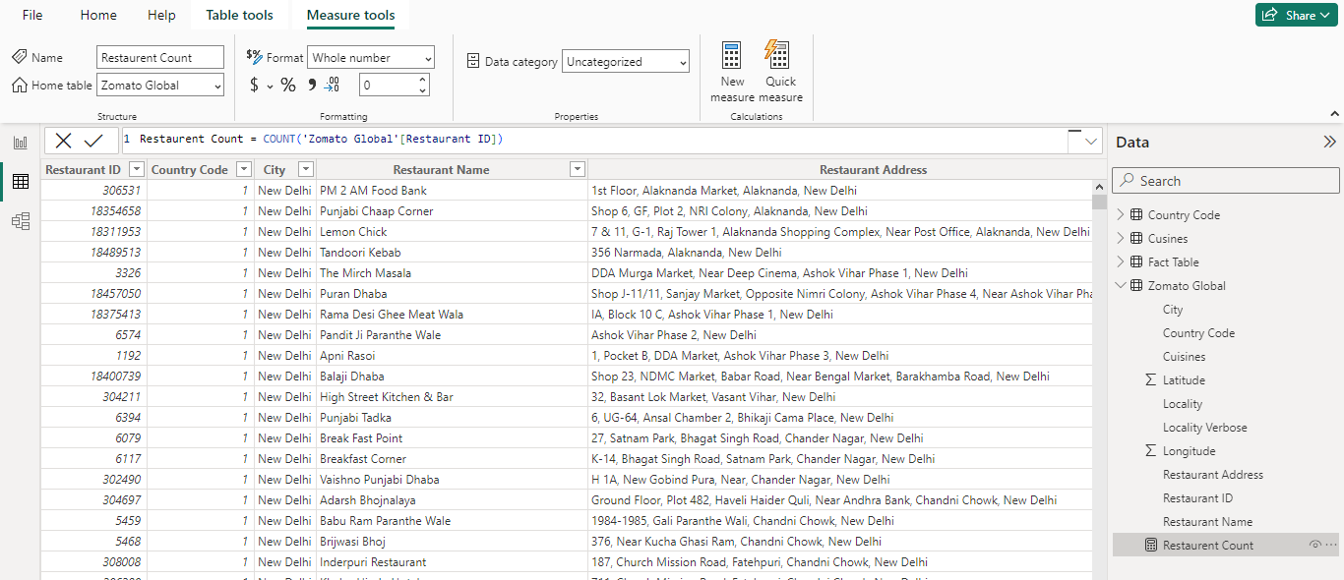

Press Enter to create the new column for the continent.

* **Creating Measures:**

Right-click on the "Zomato Global" table and select "New Measure."

Name the measure "Restaurant Count" and use the formula:

Restaurant Count = COUNT('Zomato Global'[Restaurant ID])

Press Enter to create the measure.

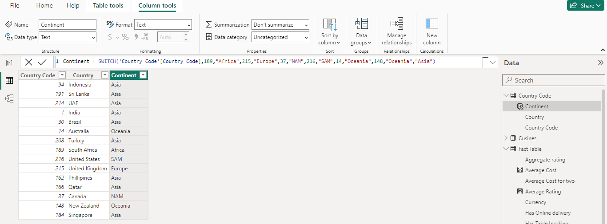

Similarly, create the following measures for the "**Fact Table**":

"Average Cost" using the formula:

Average Cost = AVERAGE('Fact Table'[Average Cost for two])

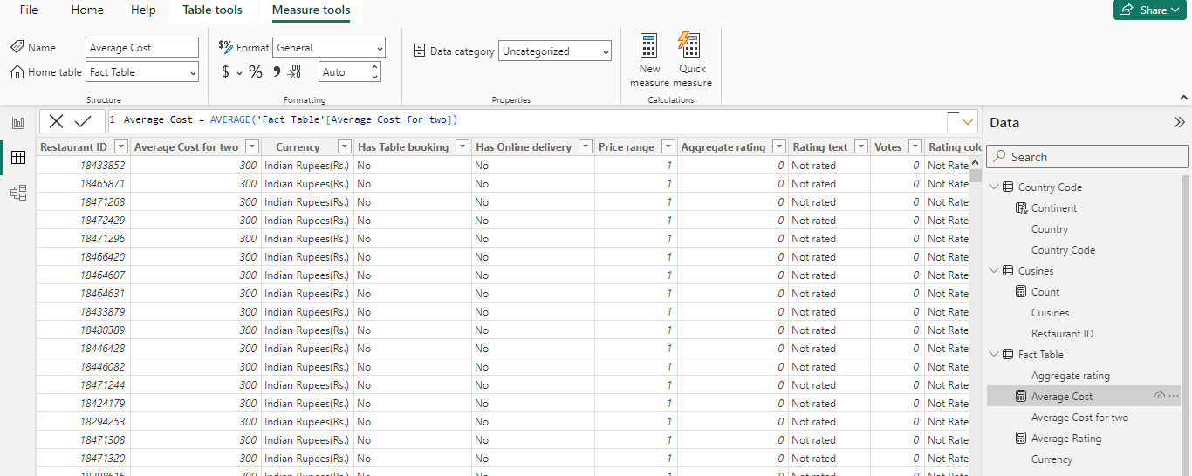

"Average Rating" using the formula:

Average Rating = AVERAGE('Fact Table'[Aggregate rating])

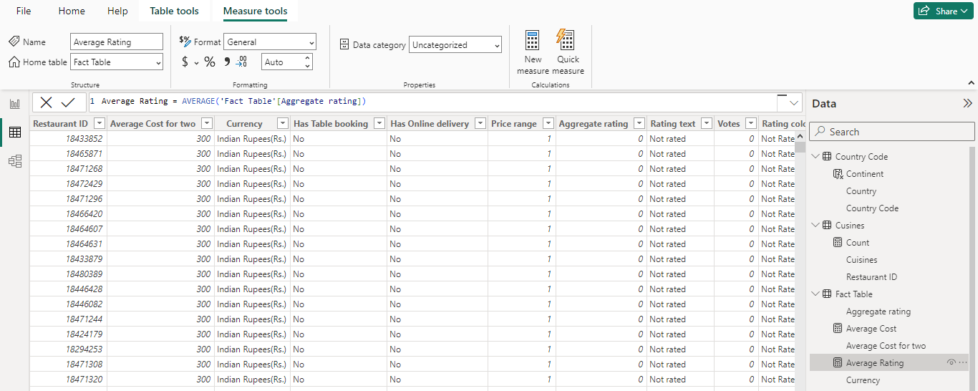

Also, create a measure for the "**Cuisines**" table named "Count" with the formula:

Count = DISTINCTCOUNT(Cuisines[Cuisines])

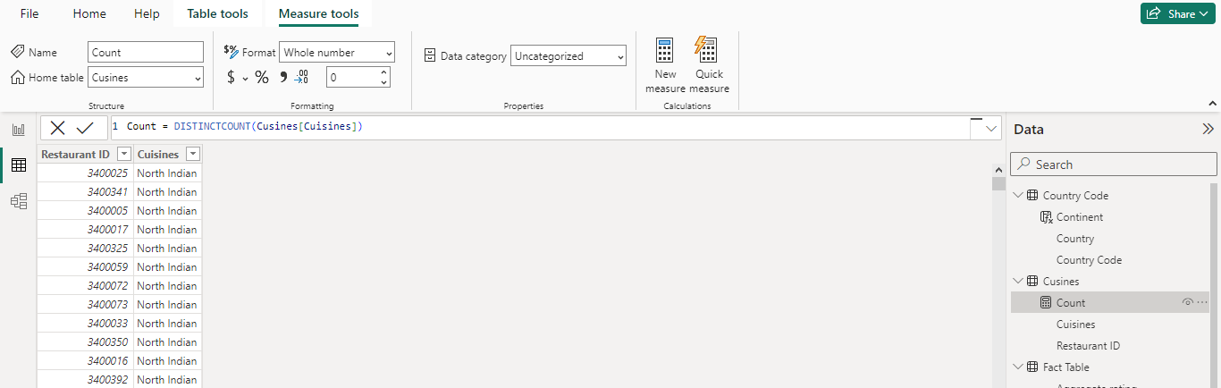

Press Enter after entering each formula to create the respective measures.

**4.2 RESULT / DASHBOARD**



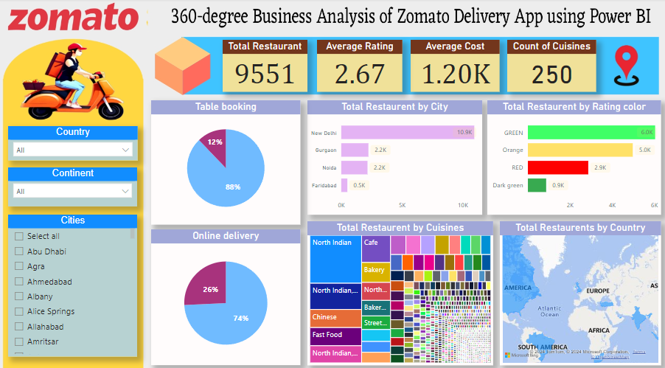

**CONCLUSION**

The project "360-Degree Business Analysis of Zomato Delivery App using Power BI" has provided comprehensive insights into the operations and performance of the Zomato delivery app across various regions. Through data analysis and visualization, we have gained valuable insights into restaurant distribution, customer preferences, and key performance indicators. The creation of interactive dashboards has enabled stakeholders to understand trends, identify opportunities, and make informed decisions.

By leveraging Power BI's capabilities, we have transformed raw data into actionable insights, allowing for better strategic planning and optimization of business processes. The project has demonstrated the power of data analytics in understanding market dynamics, improving service quality, and enhancing customer satisfaction.

Overall, the project has showcased the importance of data-driven decision-making in the online delivery industry. Moving forward, these insights will serve as a foundation for further optimization and innovation within the Zomato delivery ecosystem, ultimately contributing to its continued success in the competitive market landscape.

**FUTURE SCOPE**

The future scope of Power BI presents a landscape of boundless possibilities. With the continuous advancement of analytics and machine learning, Power BI stands poised to revolutionize data-driven decision-making. Incorporating predictive analytics capabilities into the platform could enable organizations to anticipate future trends and customer behaviors based on historical data patterns. This foresight could empower businesses to proactively address customer needs, driving enhanced customer satisfaction and loyalty.

Furthermore, Power BI's seamless integration with diverse data sources opens avenues for a more comprehensive understanding of business operations. By incorporating data from various sources such as IoT devices, social media platforms, and cloud databases, organizations can gain deeper insights into their operations and customer interactions. However, as data privacy and security concerns escalate, future iterations of Power BI projects must prioritize robust data governance frameworks. Implementing stringent data protection measures will ensure the secure handling of sensitive information and compliance with regulatory requirements.

Looking ahead, the integration of real-time data streams holds immense potential for Power BI projects. By leveraging real-time data feeds, organizations can access up-to-the-minute insights, enabling agile decision-making and response to changing market dynamics. This real-time capability could transform the way businesses interact with their data, fostering agility and adaptability in an increasingly dynamic business environment.

In conclusion, the future of Power BI is characterized by its ability to drive innovation, agility, and actionable insights. By harnessing the platform's advanced analytics, seamless data integration, and real-time capabilities, organizations can unlock new opportunities for growth, efficiency, and competitive advantage in the digital age.

**REFERENCES**

<https://learn.techsaksham.org/>

<https://portal.naanmudhalvan.tn.gov.in/>

**LINKS**

<https://github.com/chinnasamy-c/power-bi>